SETTING UP NETWORKING SIMULATION TOOLS AND INSTALLING WIRESHARK FOR NETWORK TRAFFIC ANALYSIS
Prepared By
Samuel Ochoche Peter
Cybersecurity Student
3MTT Cybersecurity Program
Date: 8th June, 2026

ABSTRACT
Network traffic analysis is a fundamental skill in cybersecurity, network administration, and digital forensics. This project focused on the installation, configuration, and utilization of Wireshark for capturing and analyzing network traffic within a home network environment. The project involved identifying active network interfaces, capturing live traffic, examining common network protocols, verifying network connectivity, and documenting implemented security controls. The analysis revealed the presence of DNS, TCP, ICMP, UDP, and TLS communications, demonstrating the practical application of packet analysis in monitoring and troubleshooting network activities. The project provided hands-on experience with network monitoring techniques commonly used by cybersecurity professionals, network administrators, and security analysts.

- INTRODUCTION
Modern computer networks form the backbone of communication systems used by individuals, businesses, and governments. As network usage continues to increase, cybersecurity professionals require tools that enable them to monitor, analyze, and secure network communications.
Wireshark is one of the most widely used network protocol analyzers in the world. It allows users to capture, inspect, and analyze packets traversing a network in real time. By examining captured traffic, security analysts can identify communication patterns, troubleshoot connectivity issues, investigate incidents, and detect suspicious activities.
This project focused on establishing a practical network monitoring environment using Wireshark. The project included software installation, network traffic capture, protocol analysis, connectivity testing, and documentation of implemented security controls.

- PROJECT OVERVIEW
This project introduced the concepts of network simulation and packet analysis through the installation and use of Wireshark.
The project aimed to provide practical experience in:
- Network monitoring
- Packet capture
- Protocol analysis
- Connectivity verification
- Security assessment
- Troubleshooting network communications
The project was conducted within a home wireless network environment.

- PROJECT OBJECTIVES
The objectives of this project were to:
- Install and configure Wireshark.
- Install and configure Npcap packet capture drivers.
- Identify active network interfaces.
- Capture live network traffic.
- Analyze common network protocols.
- Verify connectivity between devices.
- Document network architecture.
- Examine implemented security controls.
- Gain practical experience with cybersecurity monitoring tools.

- PROJECT SCOPE
This project falls under the area of Network Monitoring and Traffic Analysis.
The scope includes:
- Packet capture
- Protocol identification
- Network connectivity testing
- Host-based security verification
- Wireless security assessment
- Network troubleshooting
The project does not involve offensive security testing or penetration testing activities.

- TOOLS AND SOFTWARE USED
Table 1: Tools Used
Tool: Wireshark 4.6.6 Purpose: Packet Capture and Analysis
Tool: Npcap Purpose: Packet Capture Driver
Tool: Windows 11 Purpose: Host Operating System
Tool: Wi-Fi Network Adapter Purpose: Network Traffic Source
Tool: Android Smartphone Purpose: Additional Network Device

- ASSETS, THREATS, AND VULNERABILITIES
6.1 Assets Identified
The following assets were identified:
• Windows Laptop • Home Router • Android Smartphone • Network Traffic • Internet Connection • Wireshark Capture Files
6.2 Potential Threats
• Packet Sniffing • Unauthorized Access • Malware Communications • Data Interception • Network Reconnaissance
6.3 Potential Vulnerabilities
• Weak Wireless Security • Unmonitored Network Traffic • Misconfigured Systems • Unauthorized Devices

- WIRESHARK INSTALLATION AND CONFIGURATION
Wireshark was downloaded from the official Wireshark website and installed successfully.
The installation included:
• Wireshark Network Analyzer • Npcap Packet Capture Driver • Protocol Analysis Components
Installation Steps:
- Downloaded Wireshark from the official website.
- Executed the installer package.
- Accepted the license agreement.
- Installed Npcap packet capture drivers.
- Completed software installation.
- Verified successful launch.
Wireshark Download Page
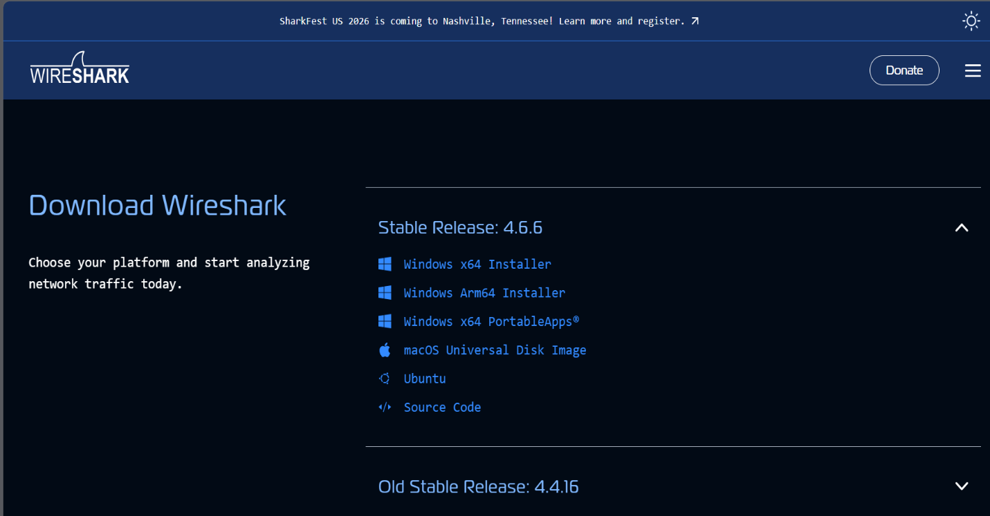
Downloaded Wireshark Installer
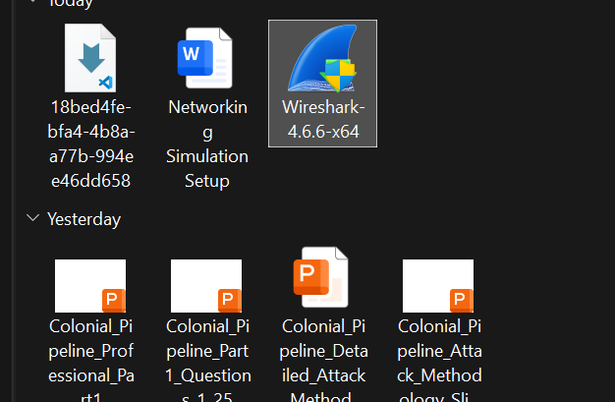

Wireshark Installation Wizard
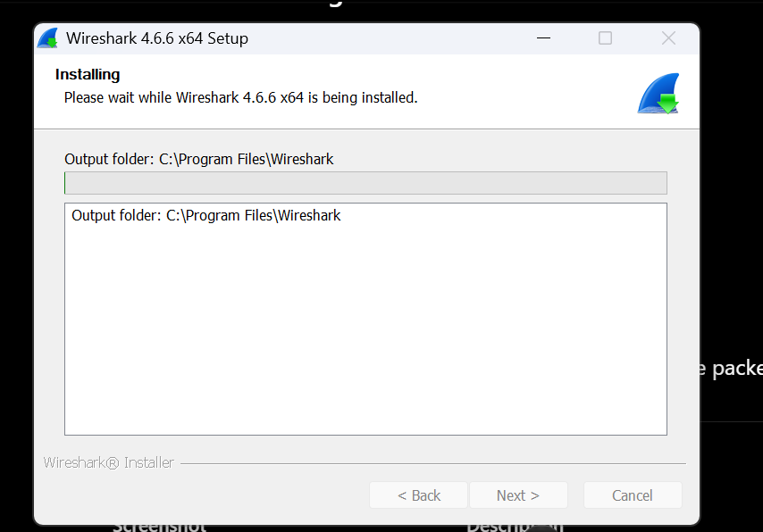

Npcap Installation
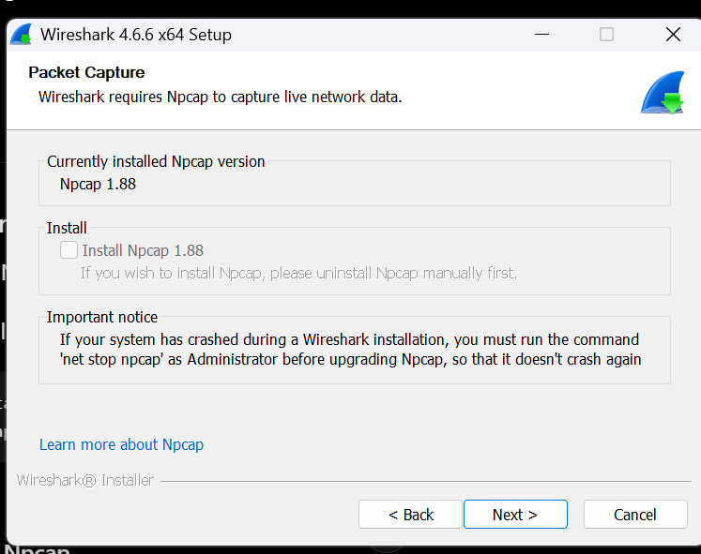
Installation Completed Successfully
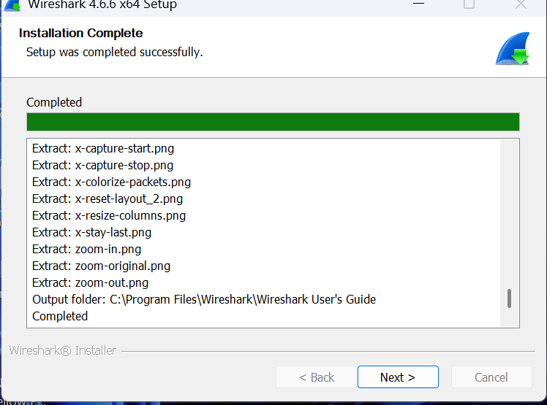

- NETWORK TOPOLOGY AND ARCHITECTURE
The monitoring environment consisted of a wireless home network.
Figure 1: Home Network Topology
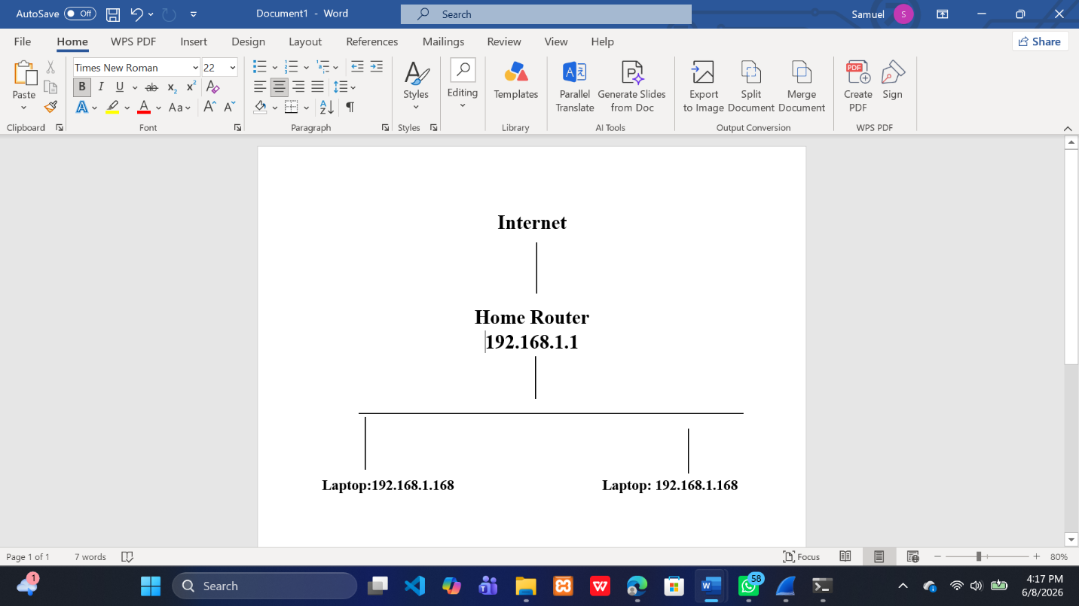
The router acted as the default gateway and provided network connectivity to all devices.
Insert Figure 1: Home Network Topology Diagram

- NETWORK DEVICE CONFIGURATION
Table 2: Connected Devices
Device: Home Router IP Address: 192.168.1.1 Function: Default Gateway
Device: Laptop IP Address: 192.168.1.168 Function: Packet Analysis Workstation
Device: Android Phone IP Address: 192.168.1.136 Function: Network Client Device
Network Configuration:
IPv4 Network: 192.168.1.0/24
Subnet Mask: 255.255.255.0
Default Gateway: 192.168.1.1
DNS Server: 192.168.1.1
Laptop IP Configuration (ipconfig)
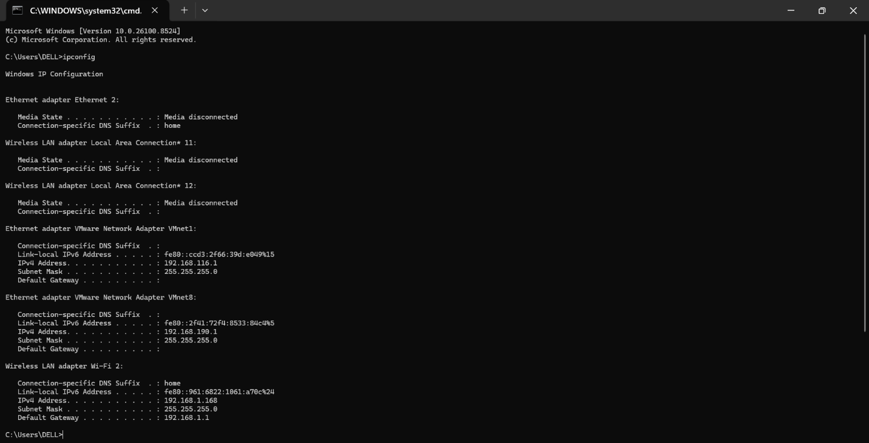

Android Network Configuration
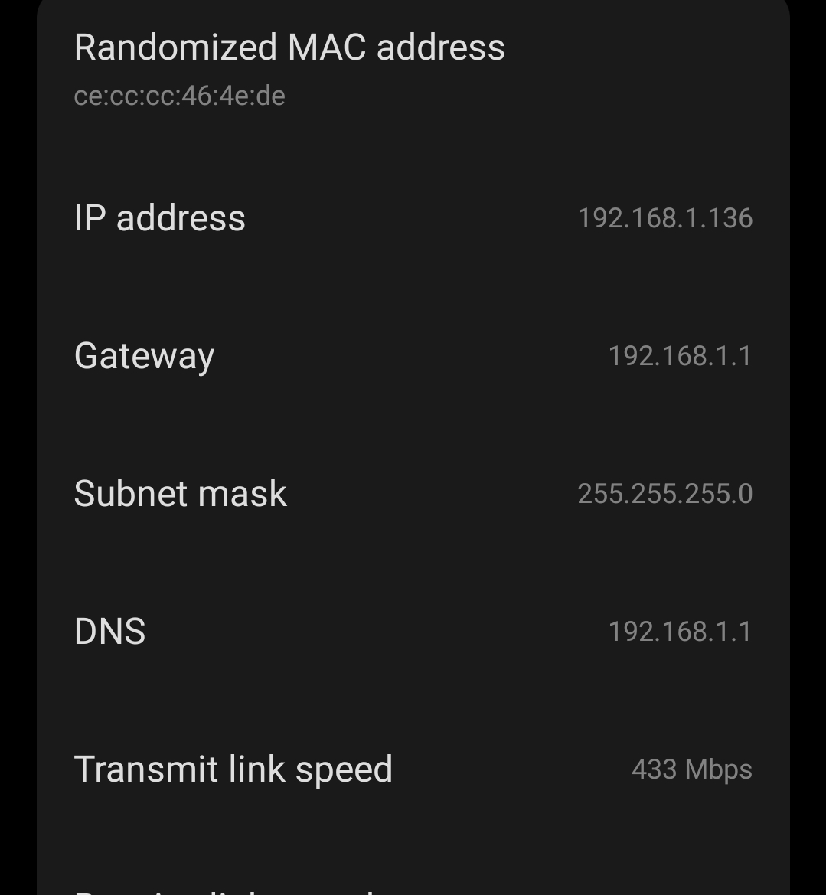
- CONNECTIVITY TESTING
Connectivity testing was performed to verify communication between devices.
Command Used:
ping 192.168.1.1
Results:
Packets Sent = 4
Packets Received = 4
Packet Loss = 0%
Average Response Time = 0ms
Interpretation:
The successful ping responses confirmed that the laptop could communicate successfully with the router.
Ping Connectivity Test
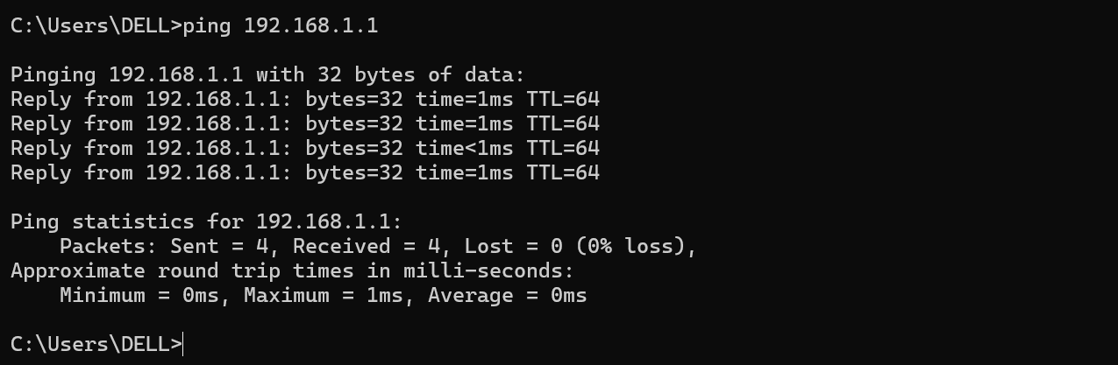

- ARP TABLE ANALYSIS
Address Resolution Protocol (ARP) was used to identify devices communicating on the local network.
Command Used:
arp -a
Purpose:
• Identify local devices • Map IP addresses to MAC addresses • Verify local communications
Findings:
• Router detected successfully • Network communications verified • Device addressing confirmed
Cybersecurity Importance:
ARP analysis assists in:
• Device discovery • Network troubleshooting • Detection of unauthorized devices • Security investigations
ARP Table Output
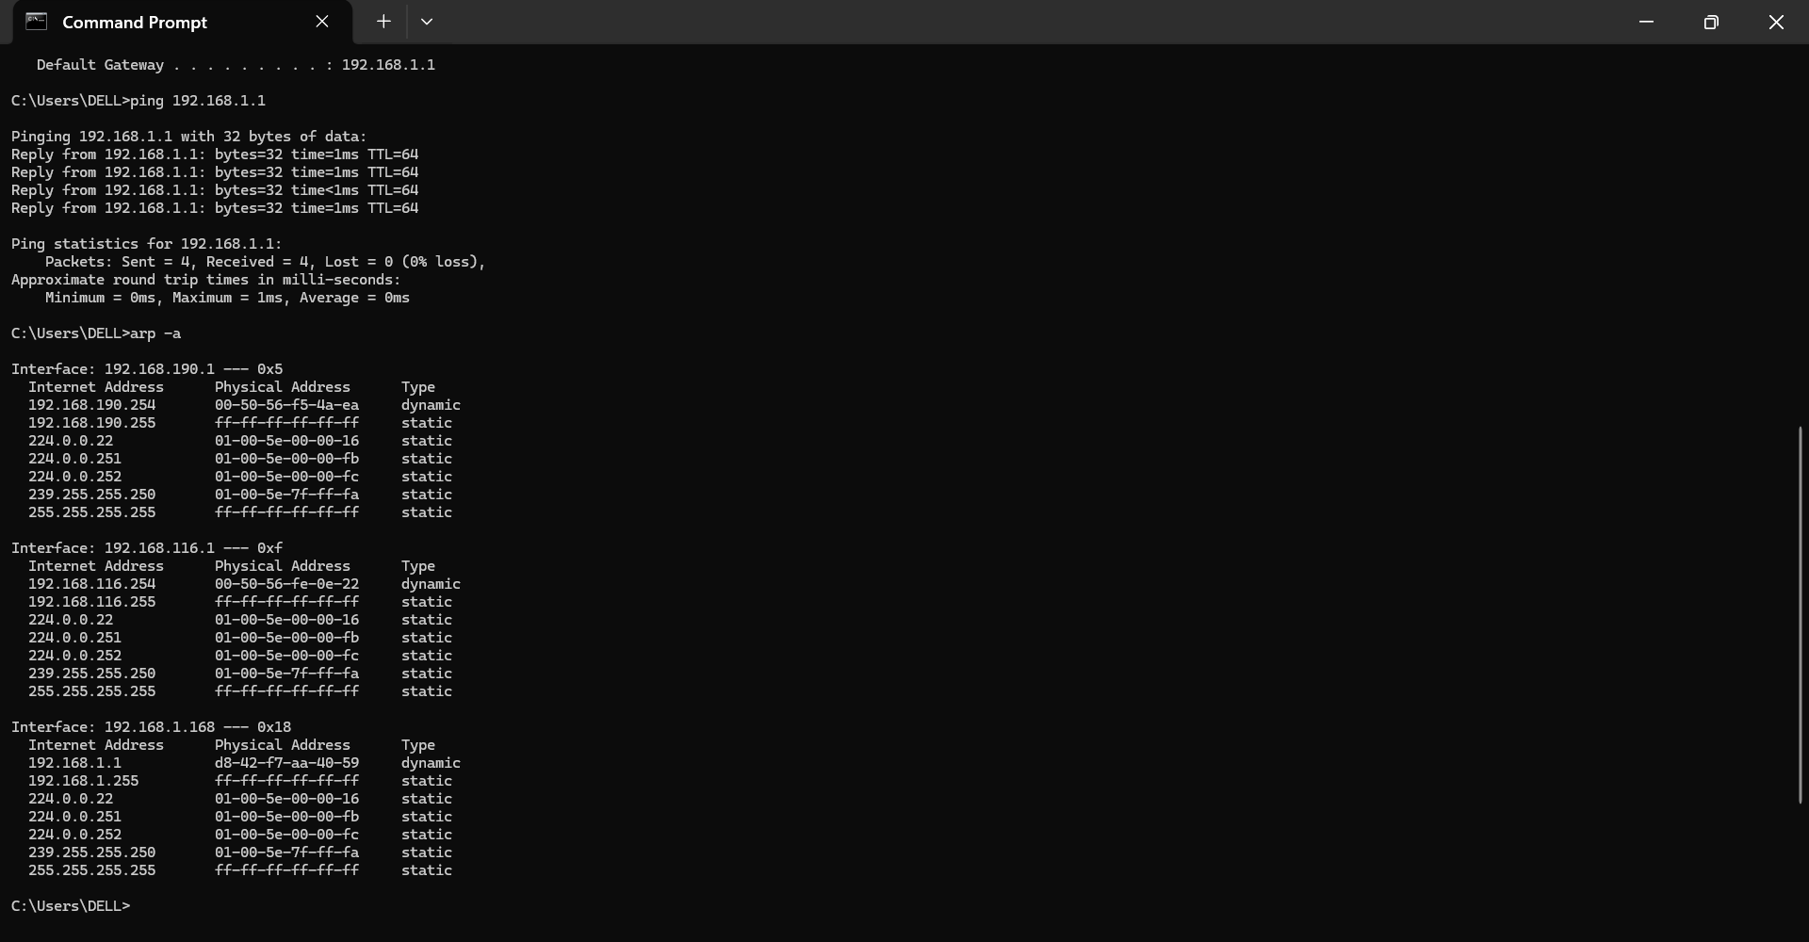

- SECURITY CONTROLS IMPLEMENTATION
12.1 Windows Defender Firewall
Windows Defender Firewall was enabled on the system.
Observed Configuration:
Firewall State: Enabled
Public Network Protection: Enabled
Inbound Connections: Restricted
Benefits:
• Blocks unauthorized access • Monitors network traffic • Reduces attack surface • Protects against malicious connections
Windows Defender Firewall Enabled
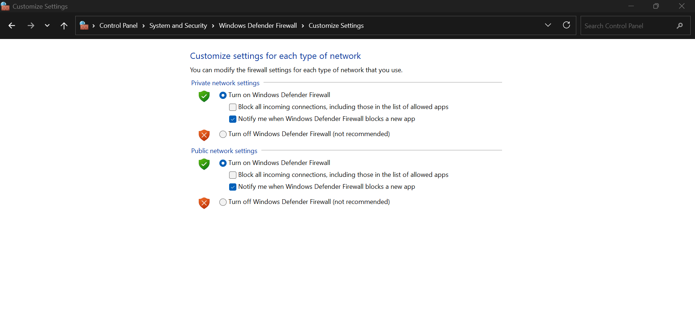

12.2 Wireless Security Assessment
Wireless security settings were examined.
Observed Security Configuration:
Security Type: WPA2-Personal
Encryption: AES
Analysis:
WPA2 with AES encryption protects wireless communications against unauthorized access and interception.
Benefits:
• Data confidentiality • Network protection • Secure wireless communications
Wireless Security Configuration
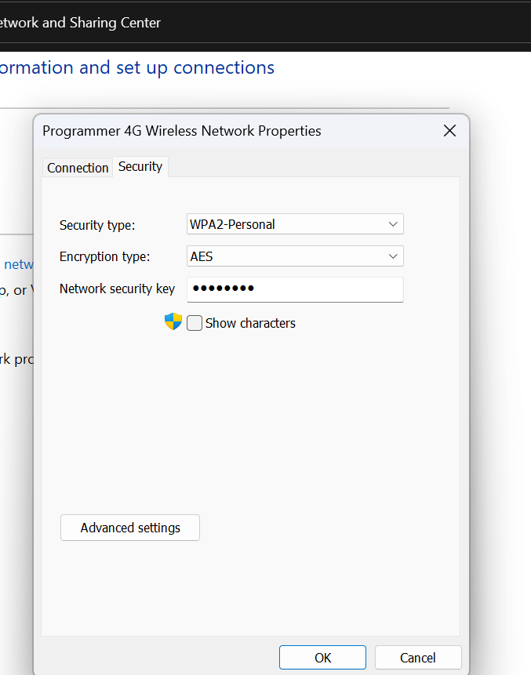
- NETWORK INTERFACE DETECTION
After launching Wireshark, several network interfaces were detected.
The active interface selected for packet capture was:
Wi-Fi 2
This interface showed active network traffic and was selected for analysis.
Available Network Interfaces
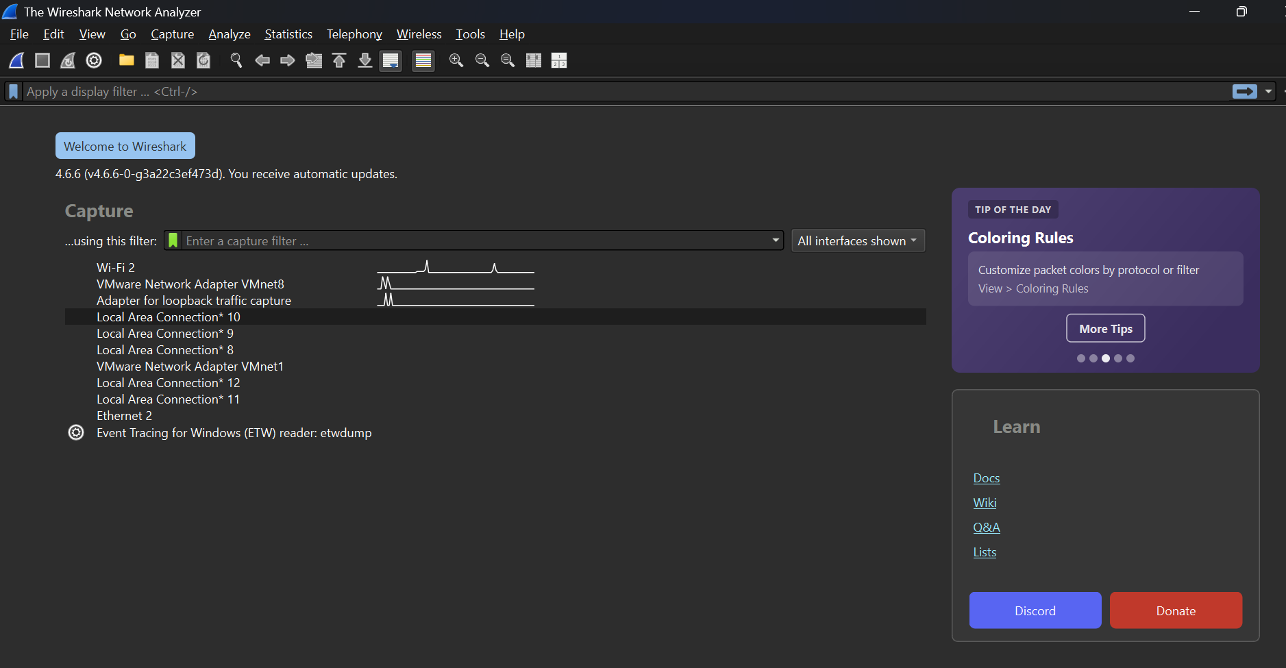

- LIVE PACKET CAPTURE
A live packet capture session was initiated on the Wi-Fi 2 adapter.
Traffic was generated through:
• Web browsing • DNS lookups • HTTPS communications • Background network activities
Wireshark successfully captured and displayed packets in real time.
Live Packet Capture
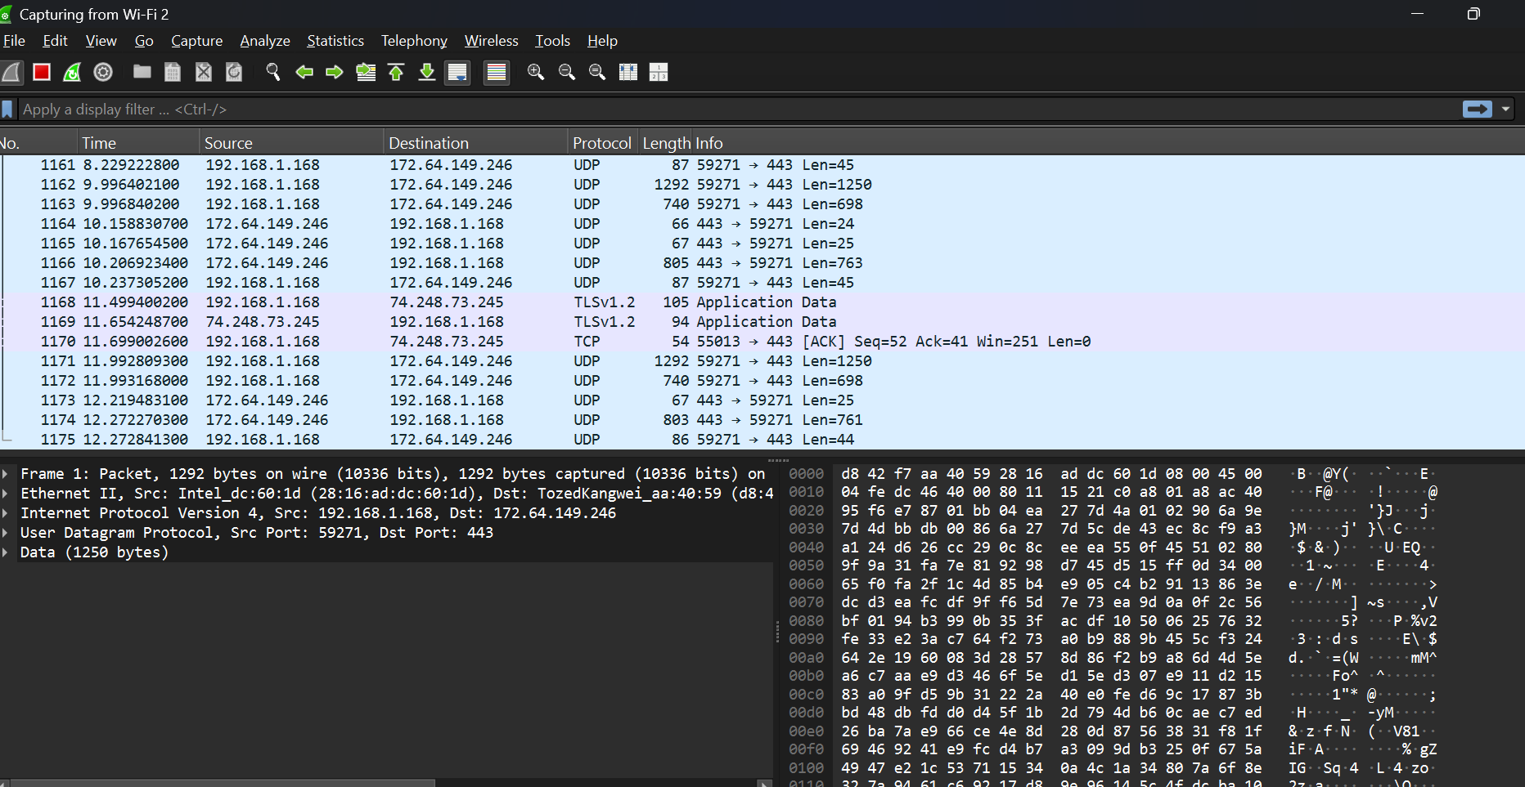

- PROTOCOL ANALYSIS
15.1 DNS Analysis
Protocol: DNS (Domain Name System)
Purpose:
DNS converts domain names into IP addresses.
Observed Activities:
• DNS Queries • DNS Responses • Name Resolution
Cybersecurity Relevance:
DNS monitoring helps identify:
• Malicious domains • Command-and-Control servers • DNS tunneling attacks
DNS Protocol Analysis
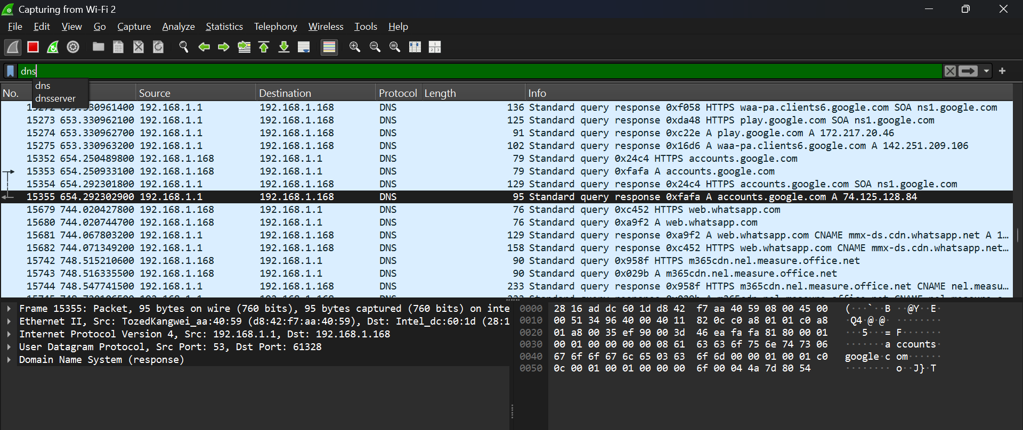

15.2 ICMP Analysis
Protocol: ICMP (Internet Control Message Protocol)
Purpose:
Used for:
• Ping Requests • Ping Replies • Network Diagnostics
Observed Activities:
• Echo Requests • Echo Responses
Cybersecurity Relevance:
ICMP is useful for:
• Connectivity testing • Host discovery • Troubleshooting
ICMP Protocol Analysis
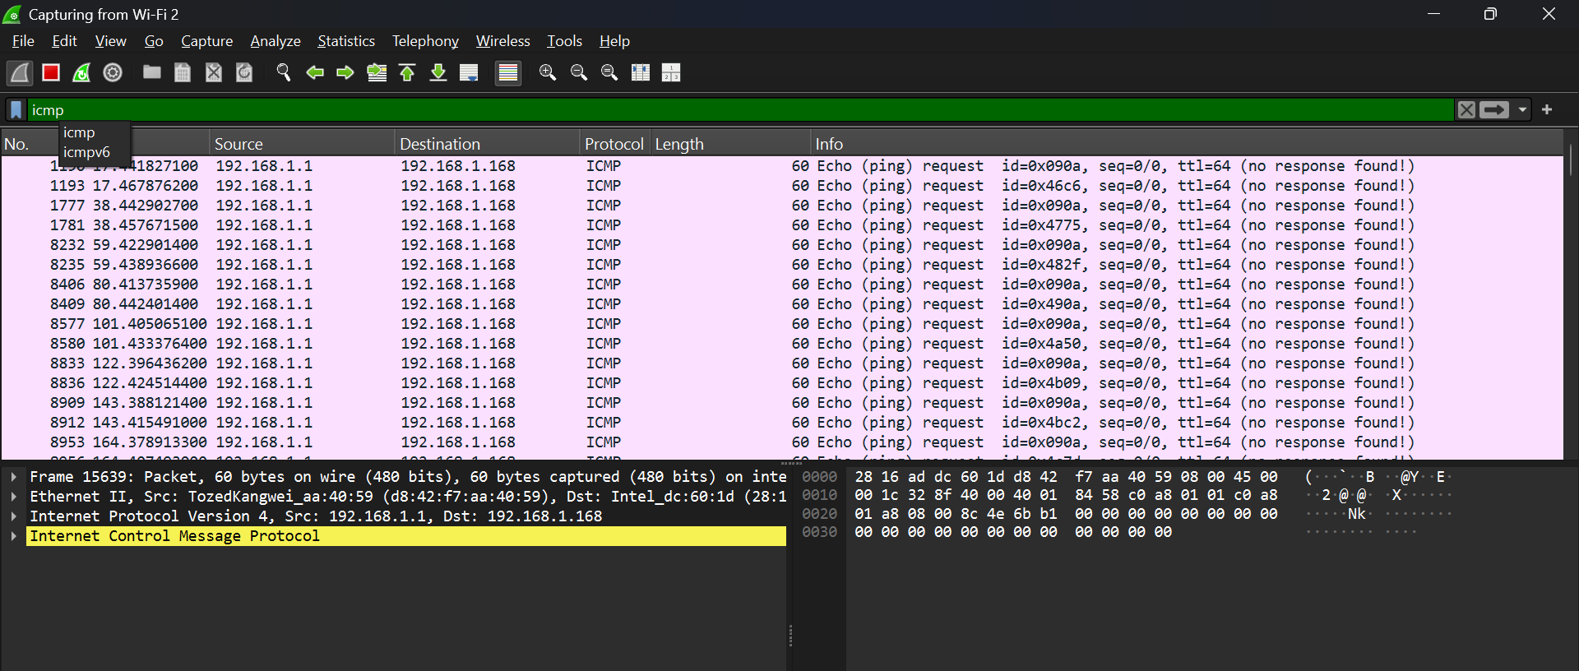

15.3 TCP Analysis
Protocol: TCP (Transmission Control Protocol)
Purpose:
Provides reliable communication between devices.
Observed Activities:
• TCP Handshake • ACK Packets • Established Connections
Cybersecurity Relevance:
TCP analysis assists in:
• Monitoring connections • Detecting anomalies • Investigating suspicious traffic
TCP Protocol Analysis
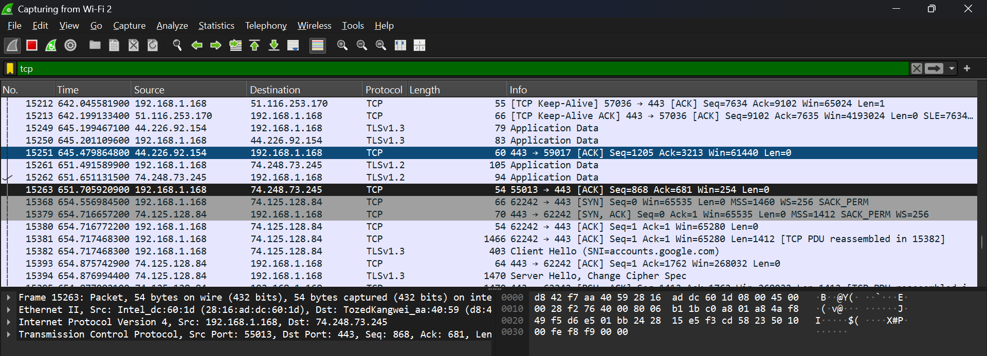

- SECURITY FINDINGS
The following protocols were observed:
• DNS • TCP • ICMP • UDP • TLS
The captured traffic demonstrated normal network communications.
No suspicious traffic was observed during the monitoring period.
Implemented Security Controls:
✓ Windows Defender Firewall Enabled
✓ WPA2 Wireless Security Enabled
✓ AES Encryption Enabled
✓ Wireshark Monitoring Implemented

- TESTING AND VALIDATION
Validation Activities Completed:
✓ Wireshark Installed Successfully
✓ Npcap Installed Successfully
✓ Interface Detection Successful
✓ Live Traffic Capture Successful
✓ DNS Analysis Successful
✓ ICMP Analysis Successful
✓ TCP Analysis Successful
✓ Connectivity Testing Successful
✓ Firewall Verification Successful
✓ Wireless Security Verification Successful

- CONCLUSION
This project successfully established a practical cybersecurity monitoring environment using Wireshark and Npcap. Live network traffic was captured and analyzed through the Wi-Fi 2 interface, enabling observation of real-world network communications.
The project demonstrated the ability to identify and analyze key network protocols including DNS, ICMP, TCP, UDP, and TLS. Network connectivity testing confirmed stable communication between devices, while ARP analysis provided visibility into local network addressing.
Security controls including Windows Defender Firewall and WPA2 wireless encryption were verified and documented. These controls contribute to protecting systems against unauthorized access and network-based threats.
The project provided valuable practical experience in packet capture, protocol analysis, network troubleshooting, security monitoring, and traffic inspection. These skills are essential for cybersecurity analysts, network administrators, SOC analysts, digital forensic investigators, and penetration testers responsible for protecting modern networks.
The objectives of the project were successfully achieved, and the implementation demonstrated the practical application of industry-standard tools for cybersecurity monitoring and network analysis.

